Name: Tanmay Vig

Roll No.: 19BCS061

Class: B. Tech 3rd year, 5th sem

Lab 10: Write a program to connect multiple clients to server.

Answer:

Source code:

Server:

import socket

from datetime import datetime

import os

HOST:str='127.0.0.1'

PORT:int=3000

thread_count:int=0

conn_list:list=[]

def chat(connection,add) -> None :

while True:

data = connection.recv(2048)

if not data or data.decode()=="bye":

break

print("{} Client {}: ".format(datetime.now(),str(add[1])) + data.decode())

connection.sendall(reply:=str.encode(input("{} Server: ".format(datetime.now()))))

if reply=="bye":

break

connection.close()

with socket.socket(socket.AF_INET, socket.SOCK_STREAM) as s:

s.bind((HOST, PORT))

s.listen()

while True:

choice= int(input("Enter:\n 1. to add new client\n 2. to chat with client\n 0 to exit\n"))

if(choice==1):

conn,add =s.accept()

print("Connected to:" + add[0]+":"+str(add[1])+" at "+str(datetime.now()))

conn_list.append((conn,add))

thread_count+=1

elif(choice==2):

if(len(conn_list)<1):

print("no connections yet!")

continue

chat(conn_list[0][0],conn_list[0][1])

conn_list.pop(0)

else:

break

client:

import socket

from datetime import datetime

HOST:str='127.0.0.1'

PORT:int=3000

with socket.socket(socket.AF_INET,socket.SOCK_STREAM) as s:

s.connect((HOST,PORT))

while True:

s.sendall(reply:=input("{} Client: ".format(datetime.now())).encode());

if reply=="bye":

break

data=s.recv(1024)

if not data or data.decode()=="bye":

break

print("{} Server: ".format(datetime.now()) +data.decode())

Output:

Server:

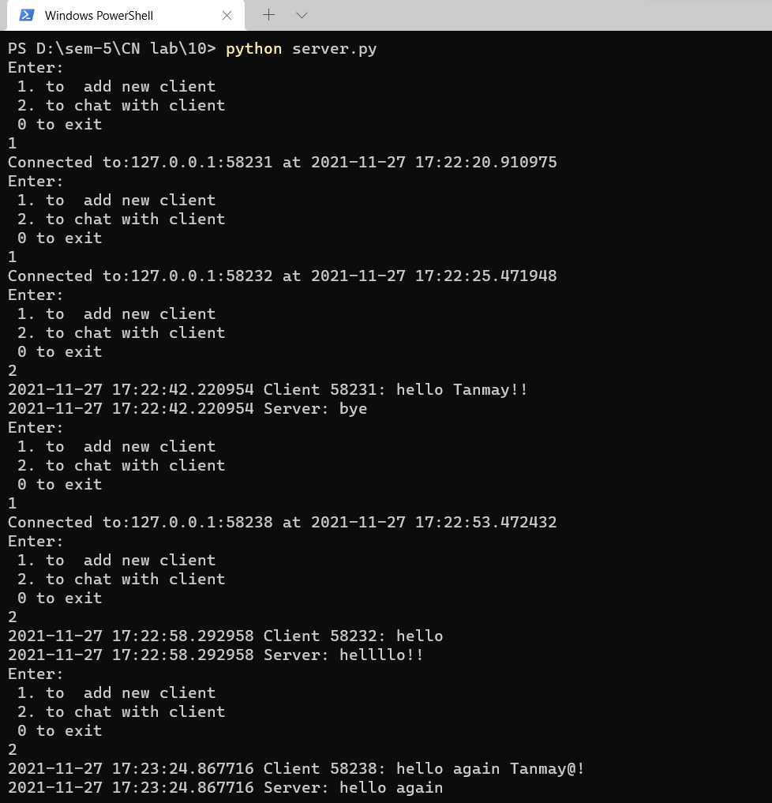

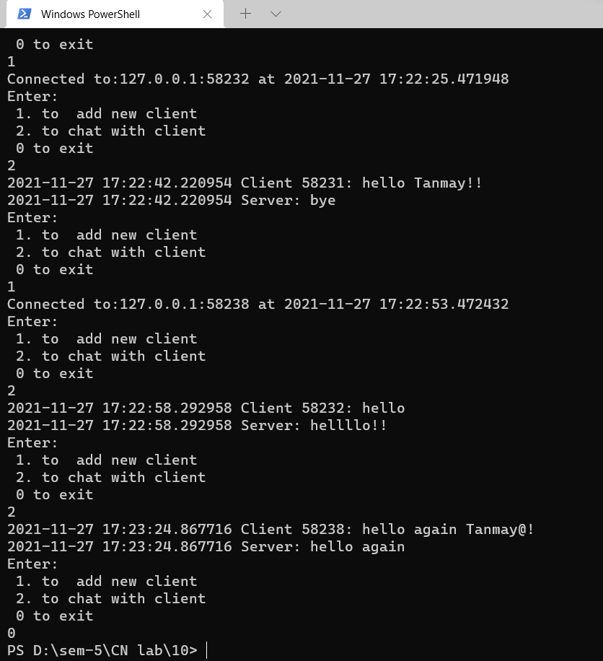

Client:

1:

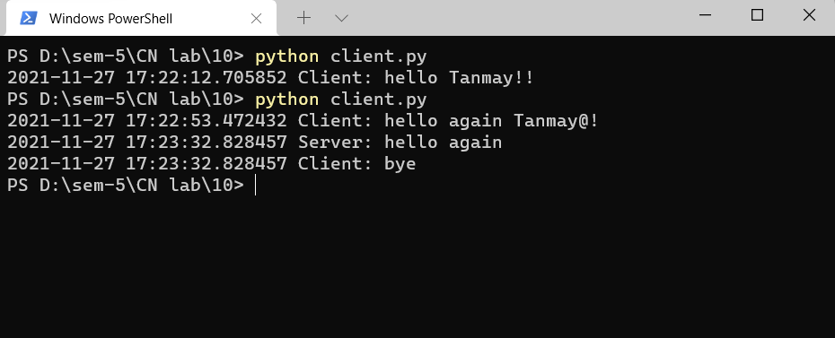

2:

